**Exercise 1 (2019-2020)**

An Phu primary school

Name : 2/ .....

Class : …………………….

**TINY TALK 1B**

**I. Choose the best answer. (3points)** ( khoanh vào đáp án đúng )

1) Play with ............ . Ok. Let’s ......

a.candy/ slide b. bear/ bread c. me/ slide

2) ......... my pillow. No, It’s my .........

a. It’s / farmer b. That’s / pillow c. He’s / doctor

3) It’s ........ . ....... cold

a. raining / I’m b. She’s / doctor c. play/ swing.

4) Red light. ………

a. Go b. Stop c. Play

5) Have .......... soup. It’s \_\_\_\_\_\_\_\_

a. hungry/ good b. some/ good c. Mmm/good

6) I ……… candy. ...... .Not today.

a. want/ No b. want/ Not c. hungry/ No

**II. Complete the short dialogue 2points.** (Hoàn thành các đoạn hội thoại sau)

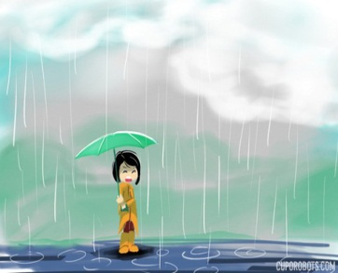

1. A: Hurry up! It’s \_\_\_\_\_\_\_\_\_\_\_.

B: I’m \_\_\_\_\_\_\_\_\_\_\_.

2. A: I want \_\_\_\_\_\_\_\_\_\_\_. 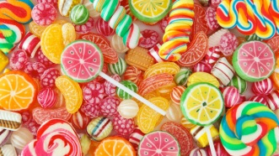

B: No, \_\_\_\_\_\_\_\_\_\_\_.

**III. Choose a correct word to write under each picture. (2 points)**

( chọn một từ đúng và viết ở dưới bước tranh)

|  |
| --- |
| chips chicken swing raining soup sunny police officer bear blanket |

|  |
| --- |
| Ex: E:\Hinh\Action\OTHER\action - hold an umbrellapng.png  raining |
| E:\Hinh\Food and drink\Food\chips\Untitled-17.gif  1.\_\_\_\_\_\_\_\_\_\_\_\_\_\_ | E:\Hinh\Job\police officer\Black and white\images 24.jpg  2.\_\_\_\_\_\_\_\_\_\_\_\_\_\_ | E:\Hinh\Food and drink\Food\soup\images (6).jpg3.\_\_\_\_\_\_\_\_\_\_\_\_\_\_ | E:\Hinh\Weather\weather-hot.png  4.\_\_\_\_\_\_\_\_\_\_\_\_\_\_ |
| E:\Hinh\Animals\wild animal\bear\images (44).jpg  5.\_\_\_\_\_\_\_\_\_\_\_\_\_\_ | E:\Hinh\Food and drink\Food\chicken\Untitled-aa35.gif  6.\_\_\_\_\_\_\_\_\_\_\_\_\_\_ | E:\Hinh\Action\swing\2014-12-27_055035.png  7.\_\_\_\_\_\_\_\_\_\_\_\_\_ | E:\Hinh\Objects\Object - furniture apng.png  8.\_\_\_\_\_\_\_\_\_\_\_\_\_\_ |

\*\*\* The end\*\*\*