**Exercise 1 (2019-2020)**

An Phu primary school

Name : 2/ .....

Class : …………………….

**TINY TALK 1B**

1. **Write the name of the pictures:**

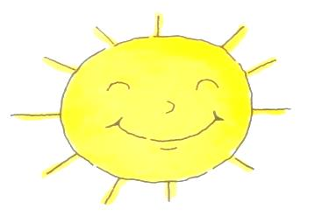 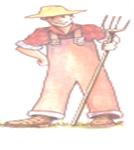 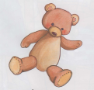

|  |
| --- |
| ___unny; ___armer.  ___illow; __ear; ___nowing; ; |

1. **It’s s**……………… **b. He’s a f**……………… **d. It’s my b**…………
2. **Choose and write the correct letter:**

**Shh! B**……… **qui** ………**.t**

**I’m h**………**ngr**………

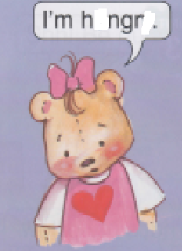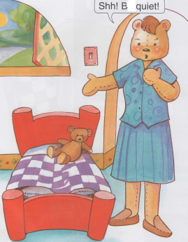

|  |
| --- |
| **e y a i u e** |

**III. Choose and write:**

…………… ! It’s ……………… **pillow.**

That’s my ……………………

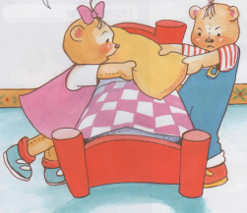

|  |
| --- |
| my ice cream pillow chicken candy No chip |

**VI. Match:**

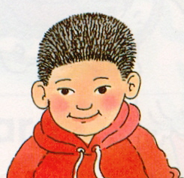

**Have some soup.**

1.

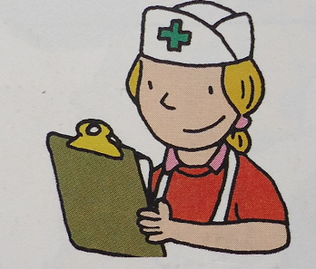

**I’m cold.**

2.

3. 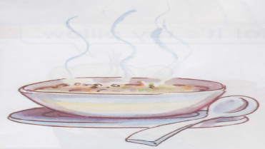 **She’s a doctor.**